Assessment :- SQL

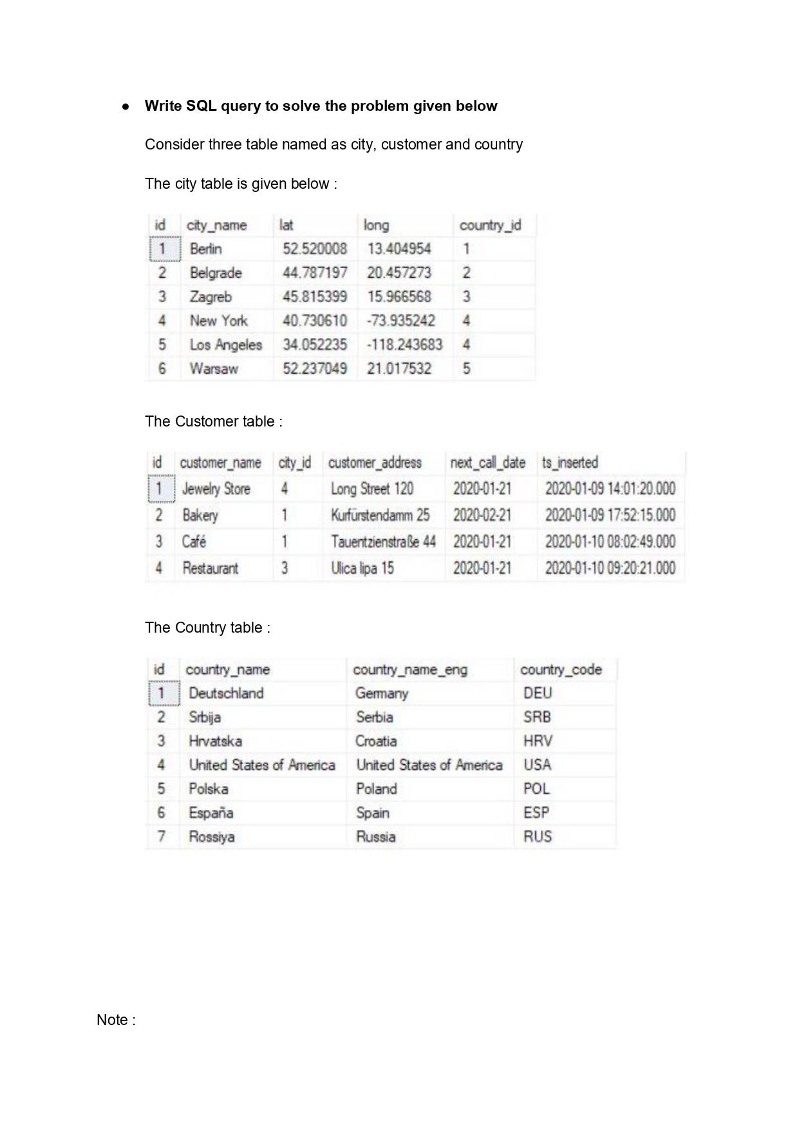

Task : 1 (join multiple tables using left join)

- List all Countries and customers related to these countries:-
Ans:-
select Country.country_name,Customer.customer_name
from country
left join City on Country.id = City.country_id
left join Customer on City.id = Customer.city_id;

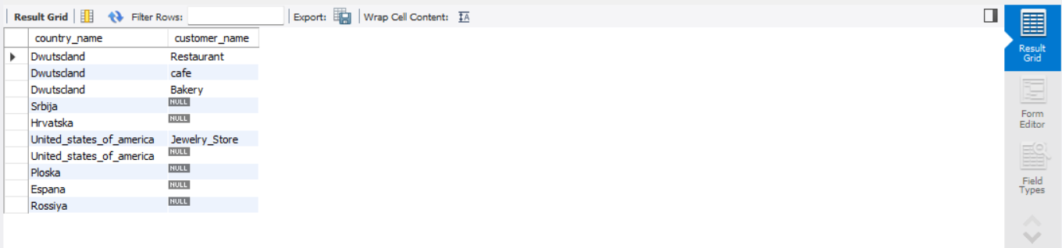

- For each country displaying its name in English, the name of the city customer is located in as well as the name of the customer:-
Ans:-
select country.country_name_eng as
country_name_english,city.city_name,customer.customer_name
from country
left join city on city.country_id = country.id
left join customer on customer.city_id = city.id;
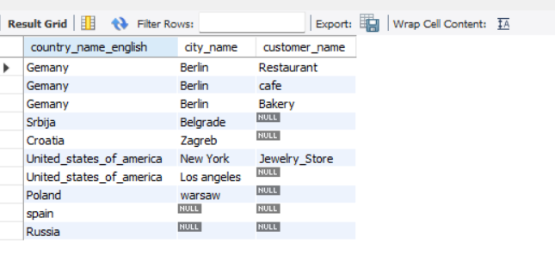

- Return even countries without related cities and customers:-
ANS:-
select co.country_name,ci.city_name,cu.customer_name
from country co
left join city ci on co.id = ci.country_id
left join customer cu on ci.id = cu.city_id;

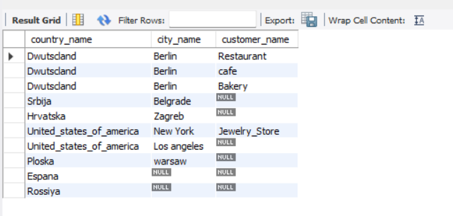

Task : 2 (join multiple tables using both left and inner join)

- Return the list of all countries that have pairs(exclude countries which are not referenced by any city). For such pairs return all customers:-
ANS:-
select co.country_name,cu.customer_name
from country co
left join city ci on co.id = ci.country_id
left join customer cu on ci.id = cu.city_id;

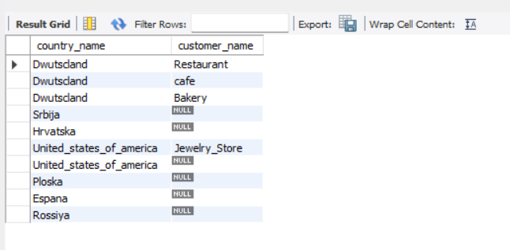

2.Return even pairs of not having a single customer :-
ANS:-

select country.country_name,country.country_code,city.city_name

from country

join city on country.id = city.country_id

left join customer on city.id = customer.city_id

where customer.id is null;

